Session 9 Work Education April 20th

- Students should all have found /organised their work experience. Forms are due today (to Ms TSA or Work education teacher).

- Students will continue with Industry OH&S module this period. They completed the General module last Term. If students are yet to complete General module – they must do this first (list of completed modules under learning tasks.) Many students are yet to complete or upload their General module (which must be finalised before moving to the next required module).

- Students choose which Industry they will complete (depending on their work experience placement). Once selected and all reading is completed, they are ready to complete the quiz and to attempt the self -assessment test (snip below)

www.education.vic.gov.au/safe@work/modules/industry/index.asp
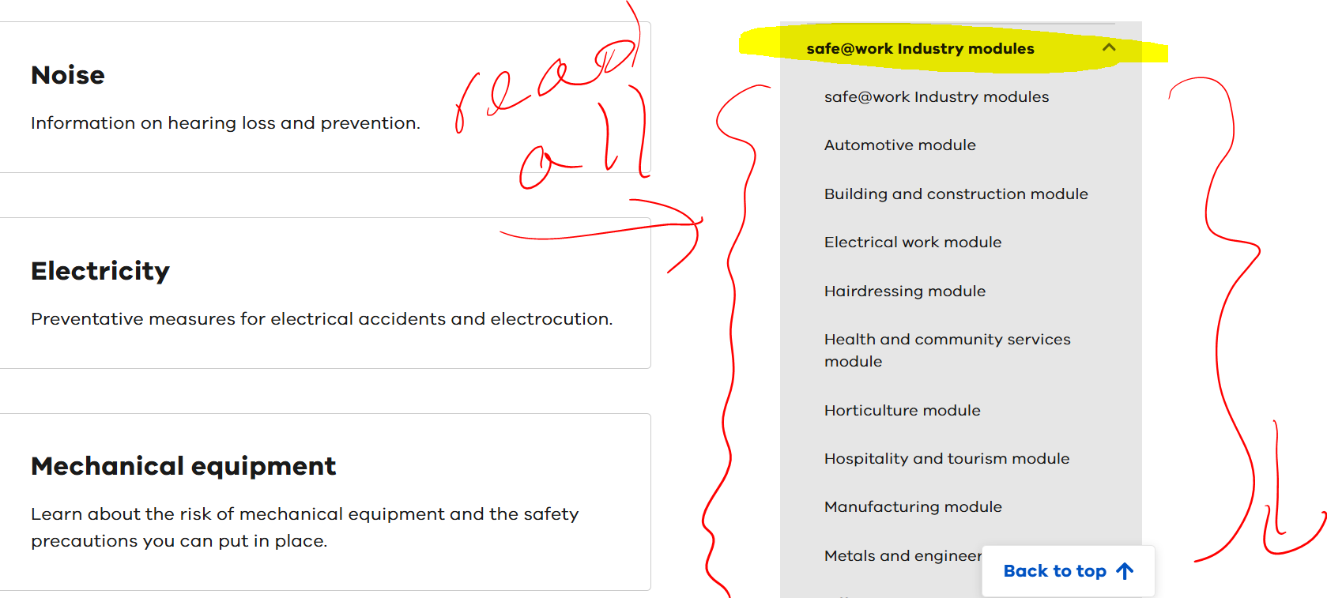

- Students click self-assessment test, then click ‘start quiz’

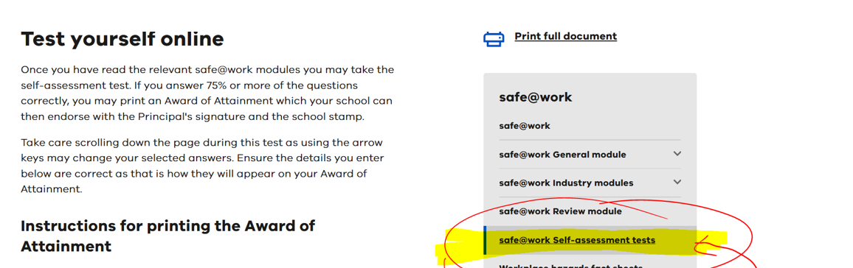
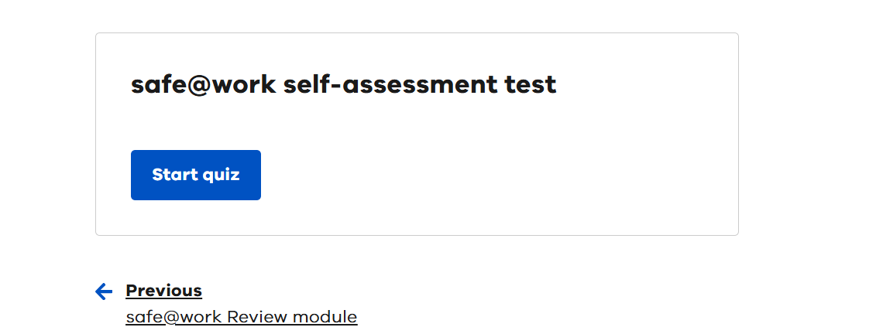

- Full name needed and School, followed by Industry assessment mode (see snip below).

They are now ready to begin the test. They must save a copy of this on their compass and print a copy and hand in to you.

